

Do your pictures lean too far forward when using a picture hanging system? HangRight Clips solve this problem!

Reduce forward leaning artwork with HangRight Clips

BEFORE

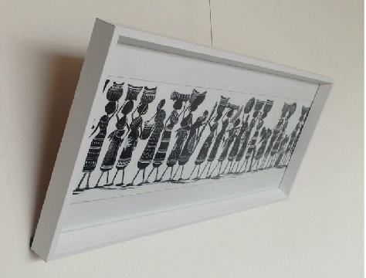

Simply fit the HangRight Clip to the back of your picture frame and your picture will sit closer to the wall.

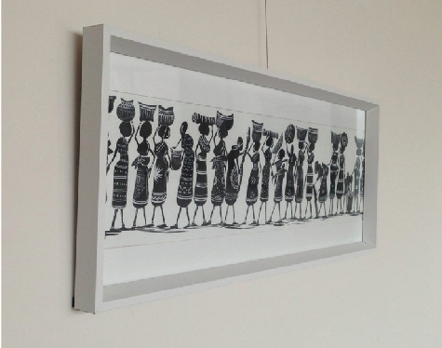

AFTER



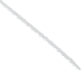

3. Simply slip Stainless Cable, Clear Tape or

Clearline hangers under the HangRight Clip



AFTER

Your picture will now sit closer to the wall and ‘HangRight’

4.

1.

Hang artwork on the Gallery Hanging System

2. BEFORE

If picture leans too far forward, install HangRight Clip

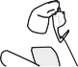

1.

Hang artwork on the Gallery Hanging System



2. BEFORE

If picture leans too far forward, install HangRight Clip

